**Crossvalidation Eval**

# DUMMY SETS

#excludeage & includeAge & CI impute & KI impute

> summary(BTEICKPD.Cv)

== Summary of a Cross Validation Performance Estimation Experiment ==

1 x 10 - Fold Cross Validation run with seed = 777

* Predictive Tasks :: base.tt.excludeAge.Proc.dummy, base.tt.includeAge.Proc.dummy, base.tt.CI.Proc.dummy, base.tt.KI.Proc.dummy

* Workflows :: svm, LMT, ada, randomForest, J48

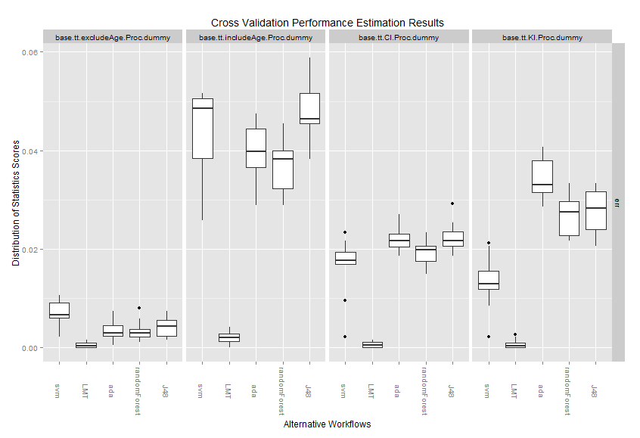

# NONDUMMY SETS

#excludeage & includeAge & CI impute & KI impute> summary(BTEICKP.Cv)

== Summary of a Cross Validation Performance Estimation Experiment ==

1 x 10 - Fold Cross Validation run with seed = 777

* Predictive Tasks :: base.tt.excludeAge.Proc2, base.tt.includeAge.Proc2, base.tt.CI.Proc2, base.tt.KI.Proc2

* Workflows :: svm, LMT, ada, randomForest, J48

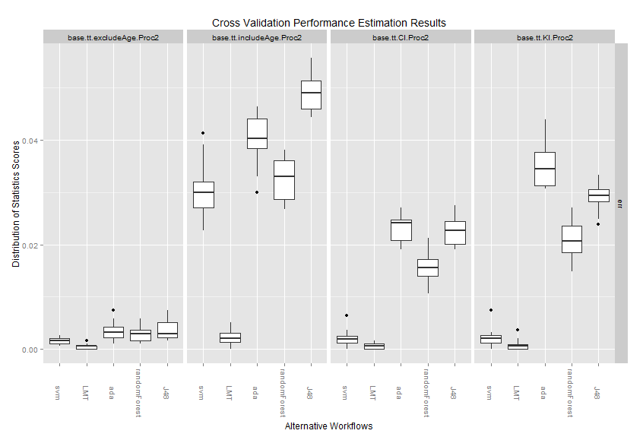

# NON-prePROC

#excludeage & includeAge

> summary(BTEI.Cv)

== Summary of a Cross Validation Performance Estimation Experiment ==

1 x 10 - Fold Cross Validation run with seed = 777

* Predictive Tasks :: base.tt.excludeAge, base.tt.includeAge

* Workflows :: svm, LMT, ada, randomForest, J48

